**COMSATS University Islamabad (CUI)**

**Department of Computer Science**

**CSC339- Data Communication and Computer Networks**

**BCS-5A   Spring 2021**

**Assignment-4     Due Date:  December 20, 2022**

**_________________________CLO-04_**

**NAME: Kulsoom Khurshid**

**REG NO: SsP20-BCS-044**

**Question 1 CLO4                                                                                                    Marks 3**

1. In CSMA/CD, after the fifth collision, what is the probability that a node chooses K = 4? The result K = 4 corresponds to a delay of how many seconds on a 10 Mbps Ethernet?

**Answer:**

collision=5th

2^5=32 so probability(p)=1/32~3%

delay=k*512*bit-time

bit-time=(1/10Mbps)=0.1us

sodelay=4*512*0.1=204.8us

1. What is the maximum number of VLANs that can be configured on a switch supporting the 802.1Q protocol? Why?

**Answer:**

* 802.1q characterizes a 12-bit VLAN tag. In that capacity, you have a greatest conceivable of 4096 qualities
* The topic of the number of a given switch can uphold is a component of its hardware and programming plan. It's normal, for instance, for a portion of these qualities to be saved for inward purposes - in this way, say, 3900-some-odd accessible out of 4096. It's additionally normal that for motivations behind price/execution compromises that a few gadgets may just help a couple hundred aggregate.
* There are likewise executions that permit more than 4096 - either by utilizing numerous, stacked 802.1q tags or dividing hardware/programming to simultaneously uphold a few 12-digit spaces (conceivably even to the place of a one of a kind 12-bit range per actual port on the switch).

**Question 2   CLO4                                                                                                        Marks 3**

1. Why is an ARP query sent within a broadcast frame? Why is an ARP?

**Answer:**

The explanation an ARP inquiry is sent inside a broadcast frame is as per the following:

* All together for a sender to send an IP datagram, the sender must know both the IP address and the MAC address.
* So as to get the obscure MAC address, the sender will send an ARP inquiry as a broadcast message over the LAN.
* Every hub will get this message and establish that it is a broadcast message. That hub/connector will at that point send the message up to its own ARP module.
* Every ARP module verifies whether that IP address coordinates its IP address.
* On the off chance that it does, it will send the ARP reaction back to the sender with the MAC address inside a frame of the packet.
* Right off the bat, it ought to be noticed that the explanation the solicitation is sent as a broadcast message is with the goal that all ARP modules get the solicitation.
* Presently, assume hubs on the system interface with various ARP modules; we would not need the ARP solicitation to just go to one module – we would require the ARP demand conveyed to all modules so the proper module may react.
* The reaction is sent from the goal ARP module legitimately to the sender with the senders MAC address and IP address in the frame for quicker informing, decreased system blockage and quicker unloading.

1. Distinguish between baseband transmission and broadband transmission.

**Answer:**

* In the baseband transmission, the entire bandwidth of the cable is consumed by a single signal. In broadband transmission, signals are sent on multiple frequencies, allowing multiple signals to be sent simultaneously.
* In baseband transmission we transmit digital signal without converting it into analog, here a low pass channel is used.
* In broadband transmission we transmit digital signal by converting it into analog. here a band pass channel is used.

**Question 3  CLO4                                                                                                          Marks 3**

Suppose that the channel bandwidth is 6 MHz Please compute the theoretical channel capacity.

**Answer:**

SNRDB = 10 x log10(SNR)

SNR = 10(SNR­DB/10)

SNR = 10 9/2

SNR = 31622.77

Hence, C = 6 x 106 x log2 (31623)

C =6 x 106 x 14.95

C = 89.7 x 106 Hz

C = 90 MHZ

**Question 4   CLO4                                                                                                       Marks 3**

1. What is the bandwidth of a signal that can be decomposed into five sine waves with frequencies at 0, 20, 50, 100, and 200 Hz? All peak amplitudes are the same. Draw the bandwidth.

**Answer:**

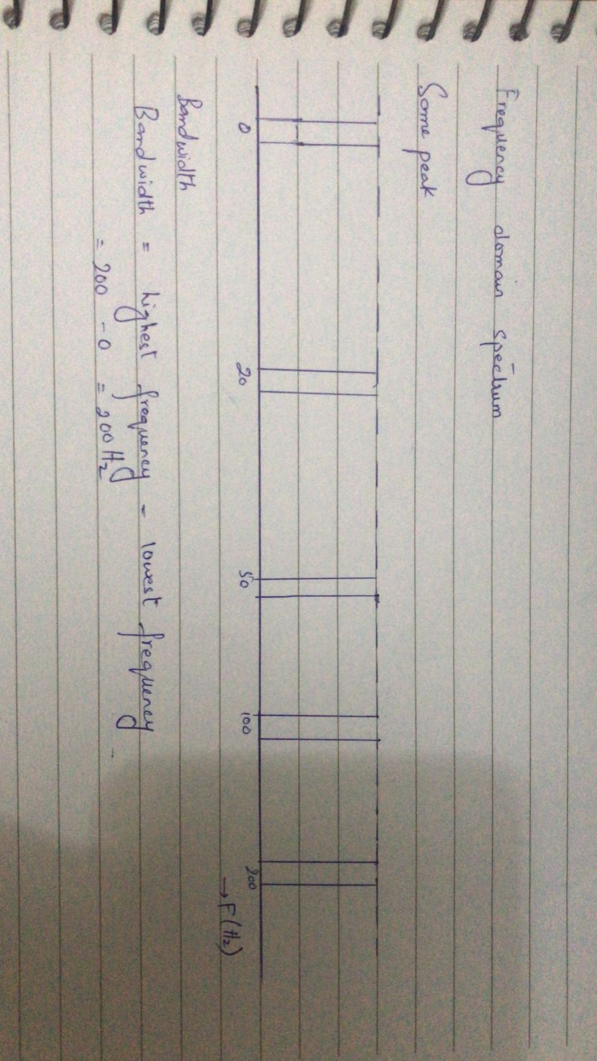

1. A periodic composite signal with a bandwidth of 2000 Hz is composed of two sine waves. The first one has a frequency of 100 Hz with a maximum amplitude of 20 V; the second one has a maximum amplitude of 5 V.  Please draw the bandwidth.

**Answer:**

Let h be the highest frequency, f. the lowest frequency and B the bandwidth. Then

From given data,

f.=100Hz

B=2000Hz

h=?

The formula of Bandwidth B=

f =B+f

=2000+100

=2100Hz

Therefore, highest frequency=2100Hz

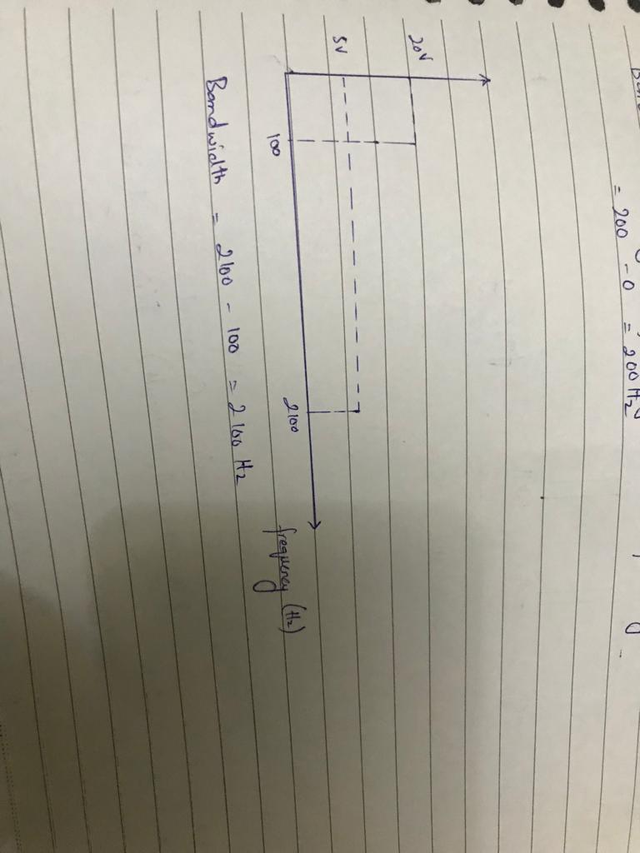From given data, the bandwidth contains low frequency 100Hz with maximum amplitude of 20V and highest frequency 2100Hz with maximum amplitude of 5V. Then,

The bandwidth diagram is

**5   CLO4                                                                                                      Marks 3**

1. What is the bit rate for each of the following signals?

**Answer:**

1. A signal in which 1 bit lasts 0.001 s

given 1 bit in 0.001s.

so bit rate Rb=1/0.001

. =1000bits/s=1kbps

1. **A signal in which 1 bit lasts 2 ms**

given 1 bit in 2ms.

so bit rate Rb=1/2ms

=1000/2

. =500bits/s=0.5kbps

1. **A signal in which 10 bits last 20**

given 10 bits in 20us

so bit rate Rb=10/20us

=10^6/2

. =5*10^6bits/s=5Mbps

1. **What is the bandwidth of the composite signal shown in the below figure?**

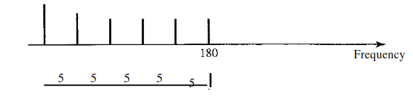

**Answer:**

Bandwidth of composite signal is the difference between the highest and lowest frequencies contained in that signal

In the given figure;

Highest frequency of component=180Hz

Lowest Frequency of signal=(180-25)=15

Bandwidth =highest frequency- lowest frequency

=180-155

Bandwidth =25Hz

**Question 6        CLO4                                                                                                                      Marks 2**

A periodic composite signal contains frequencies from 10 to 30 kHz, each with an amplitude of 10 V. Draw the frequency spectrum?

**Answer:**

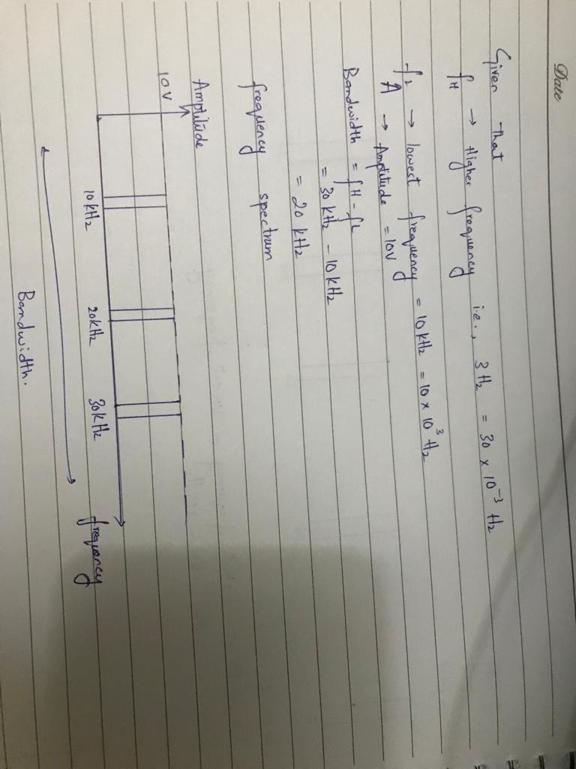

**Question 7   CLO4                                                                                                         Marks**

Suppose four active nodes—nodes A, B, C and D—are competing for access to a channel using slotted ALOHA. Assume each node has an infinite number of packets to send. Each node attempts to transmit in each slot with probability p. The first slot is numbered slot 1, the second slot is numbered slot 2, and so on.

1. What is the probability that node A succeeds for the first time in slot 5?
2. 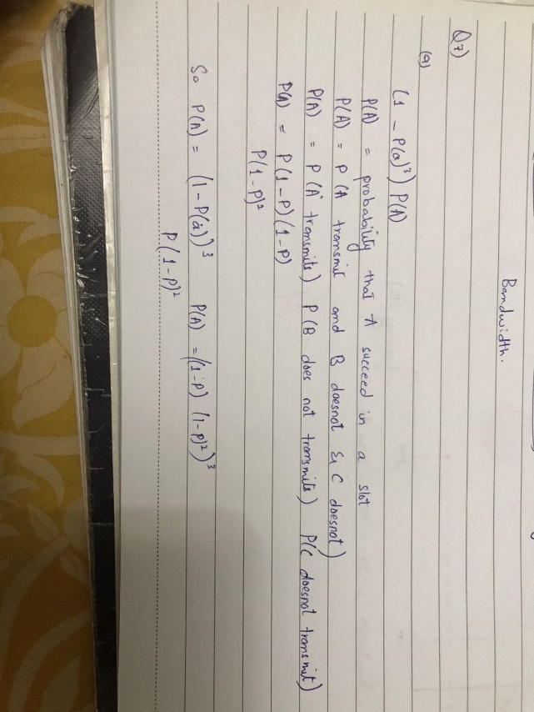What is the probability that some node (either A, B, C or D) succeeds in slot 4?
3. What is the probability that the first success occurs in slot 3?
4. What is the efficiency of this four-node system?
5. **Answer:**

